**Lecture 6.3. While loops (continued)**

**Q1. Continue statements**

The following code block on the right iterates over numbers from 0 to n and prints out odd numbers.

|  |  |  |  |
| --- | --- | --- | --- |
| **Line** | **n** | **i** | **print statements** |
|  |  |  |  |
|  |  |  |  |
|  |  |  |  |
|  |  |  |  |
|  |  |  |  |
|  |  |  |  |
|  |  |  |  |
|  |  |  |  |
|  |  |  |  |
|  |  |  |  |
|  |  |  |  |
|  |  |  |  |
|  |  |  |  |
|  |  |  |  |
|  |  |  |  |
|  |  |  |  |
|  |  |  |  |
|  |  |  |  |
|  |  |  |  |
|  |  |  |  |
|  |  |  |  |
|  |  |  |  |
|  |  |  |  |
|  |  |  |  |
|  |  |  |  |
|  |  |  |  |
|  |  |  |  |
|  |  |  |  |
|  |  |  |  |
|  |  |  |  |
|  |  |  |  |
|  |  |  |  |

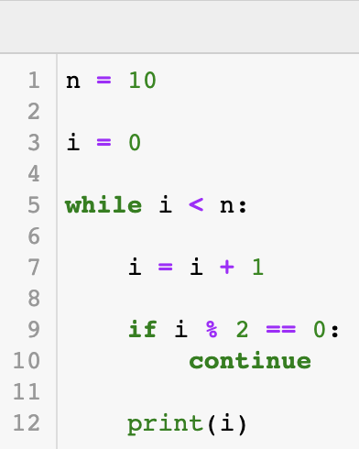

**Q2. Break statements**

Prime numbers are natural numbers greater than 1 that are only divisible by 1 and themselves.

For a givenpositive integer num, the code block on the right checks if it is prime or not.

|  |  |  |  |
| --- | --- | --- | --- |
| **Line 1** | **num = 4** | | |
| **Line #** | **num** | **i** | **is_prime** |
|  |  |  |  |
|  |  |  |  |
|  |  |  |  |
|  |  |  |  |
|  |  |  |  |
|  |  |  |  |
|  |  |  |  |
|  |  |  |  |
|  |  |  |  |
|  |  |  |  |
|  |  |  |  |
|  |  |  |  |
|  |  |  |  |
|  |  |  |  |
|  |  |  |  |
|  |  |  |  |
|  |  |  |  |
|  |  |  |  |
|  |  |  |  |
|  |  |  |  |
|  |  |  |  |
|  |  |  |  |
|  |  |  |  |

|  |  |  |  |
| --- | --- | --- | --- |
| **Line 1** | **num = 5** | | |
| **Line #** | **num** | **i** | **is_prime** |
|  |  |  |  |
|  |  |  |  |
|  |  |  |  |
|  |  |  |  |
|  |  |  |  |
|  |  |  |  |
|  |  |  |  |
|  |  |  |  |
|  |  |  |  |
|  |  |  |  |
|  |  |  |  |
|  |  |  |  |
|  |  |  |  |
|  |  |  |  |
|  |  |  |  |
|  |  |  |  |
|  |  |  |  |
|  |  |  |  |
|  |  |  |  |
|  |  |  |  |
|  |  |  |  |
|  |  |  |  |
|  |  |  |  |

**Q3.**

|  |  |  |  |  |
| --- | --- | --- | --- | --- |
| **prime_count** | **nth_prime** | **i** | **j** | **is_prime** |
|  |  |  |  |  |
|  |  |  |  |  |
|  |  |  |  |  |
|  |  |  |  |  |
|  |  |  |  |  |
|  |  |  |  |  |
|  |  |  |  |  |
|  |  |  |  |  |
|  |  |  |  |  |
|  |  |  |  |  |
|  |  |  |  |  |
|  |  |  |  |  |
|  |  |  |  |  |
|  |  |  |  |  |
|  |  |  |  |  |
|  |  |  |  |  |
|  |  |  |  |  |
|  |  |  |  |  |
|  |  |  |  |  |
|  |  |  |  |  |
|  |  |  |  |  |
|  |  |  |  |  |
|  |  |  |  |  |
|  |  |  |  |  |
|  |  |  |  |  |
|  |  |  |  |  |
|  |  |  |  |  |
|  |  |  |  |  |
|  |  |  |  |  |
|  |  |  |  |  |
|  |  |  |  |  |
|  |  |  |  |  |
|  |  |  |  |  |
|  |  |  |  |  |
|  |  |  |  |  |
|  |  |  |  |  |
|  |  |  |  |  |
|  |  |  |  |  |
|  |  |  |  |  |
|  |  |  |  |  |
|  |  |  |  |  |
|  |  |  |  |  |
|  |  |  |  |  |
|  |  |  |  |  |
|  |  |  |  |  |
|  |  |  |  |  |

|  |  |  |  |  |
| --- | --- | --- | --- | --- |
| **prime_count** | **nth_prime** | **i** | **j** | **is_prime** |
|  |  |  |  |  |
|  |  |  |  |  |
|  |  |  |  |  |
|  |  |  |  |  |
|  |  |  |  |  |
|  |  |  |  |  |
|  |  |  |  |  |
|  |  |  |  |  |
|  |  |  |  |  |
|  |  |  |  |  |
|  |  |  |  |  |
|  |  |  |  |  |
|  |  |  |  |  |
|  |  |  |  |  |
|  |  |  |  |  |
|  |  |  |  |  |
|  |  |  |  |  |
|  |  |  |  |  |
|  |  |  |  |  |
|  |  |  |  |  |
|  |  |  |  |  |
|  |  |  |  |  |
|  |  |  |  |  |
|  |  |  |  |  |